Survey of the Culex quinquefasciatus (Diptera: Culicidae) Mosquito and the Transmission of West Nile Virus in Brazos County

Kelbi Padilla
Texas A&M University, Department of Entomology

Edited by: Matthew Martinez

Abstract: Localities in the College Station area of Texas were surveyed for Culicidae species to examine the prevalence of Culex quinquefasciatus (Dipter: Culicidae). A recent outbreak of West Nile Virus (WNV) in a nearby suburb of Houston caused by salvarian transmission of Culex q. deems it a medically significant vector worthy of surveillance. Mosquito specimens were collected using Center of Disease Control (CDC) light traps in various recreational parks with proximity to water and moderate human activity, as is preferred by the organism. Collection procedures were implemented during warm, humid months due to mosquito populations peaking at this time.
Through trapping, preservation, and identification with pictorial keys, the prevalence of Culicidae species was determined. It was found that while Culex q. poses health threats as a vector of WNV, Aedes aegypti is over three times more abundant in Brazos County. Thus, our research serves to reduce the risk associated with Culex q. and allows for future areas of surveillance that focus on a more widespread species in College Station and surrounding regions.

Keywords: Culex quinquefasciatus, Culicidae, mosquito survey, West Nile Virus

Mosquitoes are capable of transmitting various diseases to humans via salvarian transmission. Their short life cycle and natural abundance make them very problematic. However, there are several other aspects to a transmission cycle that need to be present to make a disease prevalent. This experiment was run to survey the mosquito populations of the Bryan/College Station area in Texas. An attempt to assess the risk of catching various vector borne diseases will be formulated from the survey results. A prediction on the
probability of new diseases arising in the area based off trends analyzed from other areas with similar climate and vector patterns will also be performed. The experiment focuses on the connection between vector populations related to epidemiology in Brazos County. The Culex quinquefasciatus will be our vector of study.

Mosquitoes populate near bodies of water because of their dependency on water for oviposition. A 2017 surveillance report shows that the number one arborovirus

activity in the state of Texas has been the West Nile Virus (Texas Department of State Health Services 2018). Counties with the highest reported West Nile Virus activity are Dallas, Tarrant, Harris, and Denton Counties with more than 100 reported activities (Texas Department of State Health Services 2018). These are counties that experience a lot of rain. The Bryan/College Station area experiences an average 40.09 inches a year in rainfall (US Climate Data 2019). For Texas this is a comparatively high number, constituting larger mosquito populations in the area. Once adulthood is reached, the mosquitoes enter their terrestrial phase of life. Adult females are classified as solenophages- they feed directly on blood vessels- while adult male mosquitoes are not. The female mosquito will pierce its proboscis into the skin, the maxillae will cut through to the capillaries where anticoagulants and pathogens will be injected. This is a crucial point in disease transmission because it has promoted the spread of disease to newly infected persons. A rise of West Nile has recently developed from this transmission tactic in the Bryan/College Station area.

The West Nile Virus was first reported in Texas in 2002, from 2002 to 2016, 5,277 human WNV cases were reported in Texas (Texas Department of State Health Services 2018). The Culex quinquefasciatus is most known for transmitting WNV and St. Louis Encephalitis virus (SLEv) (Hill and Connelly 2013). It has been found that the majority of mosquitoes collected between March 1 and November 9, 2005 that can
transmit West Nile Virus in Harris County, Texas, were predominantly (≈95%) Culex q. (Goudarz, et al. 2007). This tropical arthropod is found in the southern US and has the characteristic of feeding indoors at night (Hill and Connelly 2013). The Culex
q. will feed on almost anything that is available, from avaians to mammals. DNA analysis of the blood meals taken in by the mosquitoes showed that between the months of March and August, the ratio between avian and mammalian were equal; between the months of September and November, the ratio had changed and were primarily mammalian-derived blood meals (Goudarz, et al. 2007). Culex q. is an opportunistic feeder and it does not discriminate on what animals it will feed on, only on what is available to them including humans. This is why it is the primary vector for West Nile Virus (Goudarz, et al. 2007). Several attempts have been made to control the Culex q.

Biopesticides and insecticides have been used, however the Culex q. has learned to quickly evolve resistance to these chemicals (Invasive Species Compendium 2018). Fish have also been utilized in controlling the larvae population. The Culex q. Is mostly a nighttime feeder, so the best way to reduce the spread WNV and population of the Culex q. at home would be to wear insect repellent, long sleeve shirts, and replace or remove outside water containers weekly (Hill and Connelly 2013).

Materials and Methods

Collection procedures and localities. The first step to determining the diseases that pose a threat to the public within the College Station area is to perform surveillance of the mosquito populations. This technique employs collecting and identifying mosquito species to assess the
prevalence of various vector borne diseases. CDC miniature light traps rented from the Texas A&M Department of Entomology laboratory were placed in neighborhood areas, specifically within small parks that contained standing water year-round due to the organism’s preference for areas of high activity and man-made water sources.
Standing water was essential to trap location because of the dependence mosquitoes place relating to egg laying. The light trap was placed out at 9:00 pm and allowed a minimum of twelve hours to run. The trap was hung four to five feet above the ground, and a battery powered light ran throughout the night. All tests were run in mid-April, a typical season that mosquitoes would be beginning to emerge because of increasing temperatures. Table 1 below contains specific information pertaining to trap set up.

Specimen preservation, identification, and imaging. Specimens were sorted by park location and stored in a plastic container within a freezer (40 °F). The genus and species from collected specimens were identified using an S6-BLED Stereo Zoom Dissecting Microscope (Microscope World, Carlsbad, CA). External morphology was examined and compared to two pictorial keys. The keys utilized to describe the species were Apperson et al. (2002), and “Keys to the Adult Female Mosquitoes of North America, North of Mexico”, received from the Texas A&M entomology department. Following identification, mosquitoes were place in sterile collection tubes (Bioquip, Rancho Dominquez, CA) with 95% ethanol and stored.

Trapping Information
Street Address | City, St | Zip Code | Date | Time
405 Live Oak | College Station, TX | 77845 | 04/09/19 | 9 pm- 10 am
10267 N Dowling Road | College Station, TX | 77840 | 04/11/19 | 9 pm-9 am
201 Holleman Dr W | College Station, TX | 77840 | 04/14/19- 04/15/19 | 9 pm-10 am

1015 Colgate Dr | College Station, TX | 77840 | 04/17/19- 04/19/19 | 9 pm-10 am

Table 1. Locality data and dates surveyed for Culicidae species in College Station, TX

Results

The trapping methods conducted did not yield any specimens, as temperature and precipitation levels during the time traps were placed were not optimal for mosquitoes. Similar work has been performed to examine the distribution of
Culicidae in Texas, and the results are presented in Table 2 (de Valdez, 2017). The most prevalent species was Aedes aegypti (35.2%) followed by Culex quinquefasciatus (11.9%), Aedes albopictus (8.9%), Culex
coronator (7.6%), Aedes vexans (7.2%), and Psorophora columbiae (6.8%). The remaining 26 species each made up less than 5% of all mosquitoes collected.

Species | A. aegypti | C. quinquefasciatus | A. albopictus | C. coronator | A. vexans | P. columbiae | Other
Prevalence | 35.2% | 11.9% | 8.9% | 7.6% | 7.2% | 6.8% | 22.4%

Table 2. Percentages of significantly distributed species
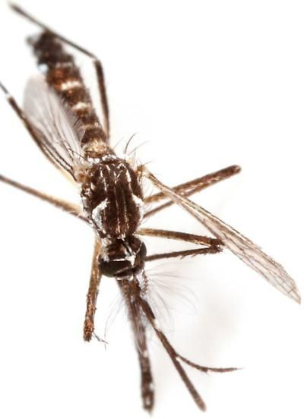

Figure 1. Aedes aegypti specimen collected and identified (Childs, 2018)

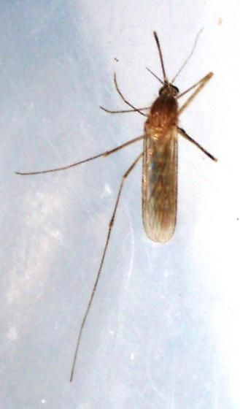

Figure 2. Culex quinquefasciatus specimen collected and identified (Childs, 2018)
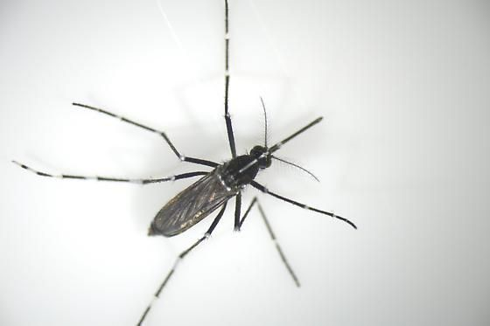

Figure 3. Aedes albopictus specimen collected and identified (Childs, 2018)

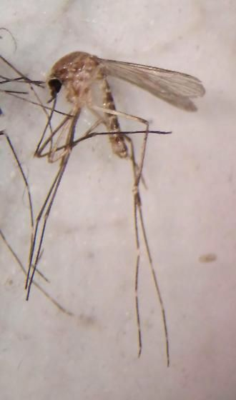

Figure 4. Culex coronator specimen collected and identified (Childs, 2018)
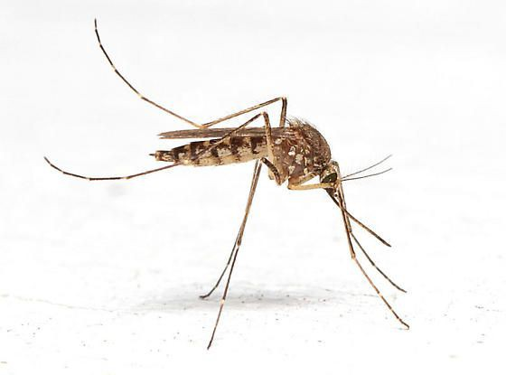

Figure 5. Aedes vexans specimen collected and identified (Childs, 2018)

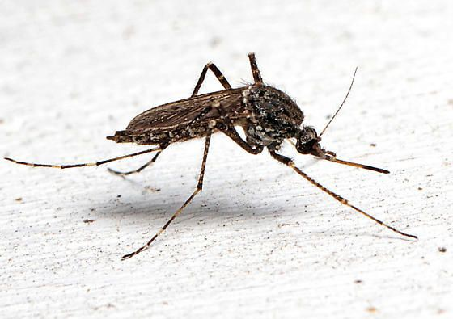

Figure 6. Psorophora columbiae specimen collected and identified (Childs, 2018)
trapping methods would have been expected

The distribution was examined on the basis of proximity to human by documenting the number of each species collected from one of three locations: urban, suburban, or rural, as seen in Table 3 (de Valdez, 2017). Since this procedure was performed following a protocol comparable to our own, the
to produce similar results. Bryan/College Station, Texas is classified as a suburban area, thus the distribution of C. quinquefasciatus is approximately equal to 6.75% of the total Culicidae population.

 | Number of Female Mosquitoes Collected (% of total)
Species | Total | Urban | Suburban | Rural
A. aegypti | 1,098 (35.18) | 181 (43.72) | 675 (42.99) | 242 (21.28)
C. quinquefasciatus | 371 (11.89) | 74 (17.87) | 106 (6.75) | 191 (16.80)
A. albopictus | 279 (8.94) | 42 (10.14) | 187 (11.91) | 50 (4.40)
C. coronator | 238 (7.63) | 17 (4.11) | 191 (12.17) | 30 (2.64)
A. vexans | 223 (7.15) | 30 (7.24) | 70 (4.46) | 123 (10.82)
P. columbiae | 213 (6.82) | 4 (0.97) | 174 (11.08) | 35 (3.08)

Table 3. Number, distribution, and proportion of mosquito species collected

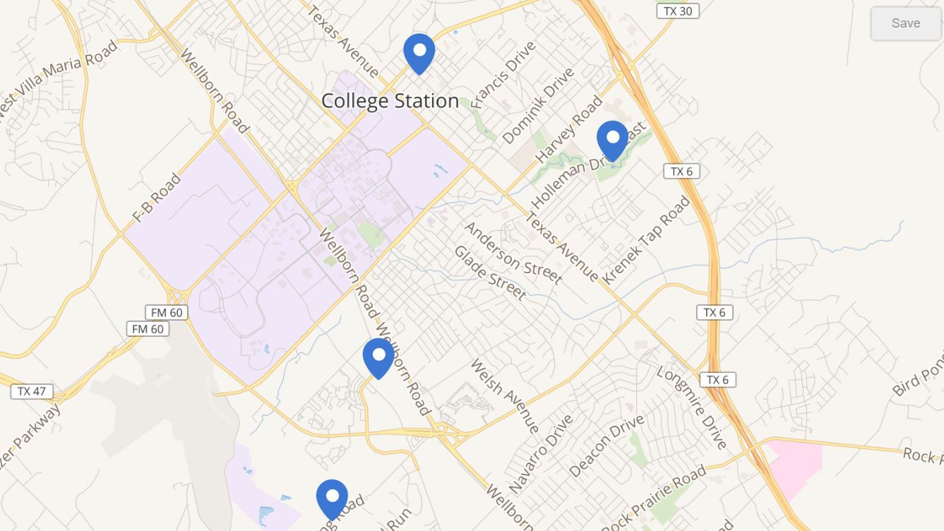
Figure 7. Locations of collection trap placement throughout College Station

Discussion

It is suspected that the trapping methods did not yield any specimen due to weather restrictions. Through various conducted studies we found that temperature is an important factor in the emergence of mosquitoes and other arthropods due to its direct effects on their mortality, life span, and development rates that can cause changes in morphology (Su and Mulla 2001, Debat et al. 2003, Gunay et al. 2011).
The extent of these effects is population specific as well as species- species specific. The species, Culex quinquefasciatus, experiences optimal growth and life expectancy in temperatures around 24°C (Ciota, Alexander T et al. 2014). The distribution patterns and common location of, Culex quinquefasciatus suggests this species is likely adapted to higher
temperatures. Existing outside of high temperatures can cause stress during development, which may result in developmental inconsistencies as well as low prevalence of the species (Ciota, Alexander T et al. 2014). The temperature that our species, Culex quinquefasciatus, needs to survive is ranged from 20°C to 30°C. Our collections were attempted when temperatures fluctuated between 14-18°C. Our temperatures were far out of the optimal growth range, which we hypothesize the cause of our traps yielding no specimen.
Figure 1 summarizes these findings by graphing larval and adult abundances in response to temperature conditions (Beck-Johnson, et al. 2013).

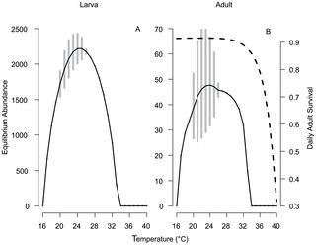

Figure 8. Larval and adult abundances in response to temperature conditions
causing infectious diseases in humans. The

Mosquitoes have specialized antennae that carry sensory capabilities, their antennae can detect carbon dioxide levels in adjacent areas. Both male and females are responsive to carbon dioxide plumes because the release of this gas in mammalian respiration. The mosquito light traps were run without the aid of Dry Ice, which sublimes and releases carbon dioxide, signalling to mosquitoes a pseudo-presence of a potential blood meal. Without applying this component to the trap, it is expected that the reliance on light alone would yield lower collections, supporting the results obtained from surveillance.
The traps were run in residential areas that contained standing water year-round (a crucial aspect to larval mosquito success). Residential areas were of preference for this experiment because the focus on medical entomology, specifically the presence of vectors that transmit pathogens capable of
experiment was to assess the risk of vector borne diseases in College Station based upon vector surveillance. Without experimental data, research was conducted to find past surveys in areas of identical climates. The survey from San Antonio (de Valdez, 2017) is viable to the study because of similar latitudinal coordinates, and therefore,comparable temperatures . San Antonio lies at 29.4241° N, while College Station is further north at 30.6280° N, an insignificant difference in the grand scheme.
Culex quinquefasciatus was confirmed in the surveillance reports, however, was found only about 12% prevalent in populations. It was then assumed that the vector’s presence was the only condition of vectorial capacity needed to transmit disease to humans.
Pathogens known to be carried by C. quinquefasciatus include the West Nile Virus, but the initial emphasis on the risk of the rise of disease occurrence corresponding

to C. quinquefasciatus, should be reconsidered. Populations were found to contain triple (36%) amounts of A. aegypti, a well-known vector of Dengue serotypes, Yellow Fever Virus, and West Nile Virus. All threats to the College Station area based upon vector presence. Confirmation of disease is unknown because inability to
experimentally determine pathogens contained within the collected specimens. Again, the study relies on the assumption that vector presence alone is enough to transmit the pathogen and cause disease in humans.

References Cited

Amelia Travassos da Rosa, Taweesak Wuithiranyagool, Robert B. Tesh (2007). Host Feeding Pattern of Culex quinquefasciatus(Diptera: Culicidae) and Its Role in Transmission of West Nile Virus in Harris County, Texas. The American Society of Tropical Medicine and Hygiene. 2007 July; 77(1): 73-81.

Apperson C. S., Harrison B. A., Unnasch T. R., Hassan H. K., Irby W. S., Savage H. M., Aspen S. E., Watson D. W., Rueda L. M., Engber B. R., Nasci R. S. (2002).
Host-feeding habits of Culex and other mosquitoes (Diptera: Culicidae) in the Borough of Queens in New York City, with characters and techniques for identification of Culex mosquitoes. J. Med. Entomol. 39: 777–785

Beck-Johnson, L. M., Nelson, W. A., Paaijmans, K. P., Read, A. F., Thomas, M. B., & Bjørnstad, O. N. (2013). The effect of temperature on Anopheles mosquito population dynamics and the potential for malaria transmission. PLOS one, 8(11), e79276.

Childs, K. 2018. Identification, Images, & Information For Insects, Spiders & Their Kin For the United States & Canada. BugGuide. (https://bugguide.net/node/view/1566358).

Ciota, Alexander T et al. “The effect of temperature on life history traits of Culex mosquitoes.”
Journal of medical entomology vol. 51,1 (2014): 55-62.

de Valdez, M. R. W. (2017). Mosquito species distribution across urban, suburban, and
semi-rural residences in San Antonio, Texas. Journal of Vector Ecology, 42(1), 184-189.

Debat V, Begin M, Legout H, David JR. Allometric and nonallometric components of Drosophila wing shape respond differently to developmental temperature. Evolution. 2003; 57: 2773–2784.

Ephantus J. Muturi, Joseph Mwangangi, Josephat Shililu, Simon Muriu, Benjamin Jacob, Charles M. Mbogo, Githure John, Robert Novak (2007). Evaluation of four sampling techniques for surveillance of Culex quinquefasciatus (Diptera: Culicidae) and other mosquitoes in African rice agroecosystems. J Med Entomol. 2007 May; 44(3): 503–508. https://www.ncbi.nlm.nih.gov/pubmed/17547238

Gunay F, Alten B, Ozsoy ED. Narrow-sense heritability of body size and its response to different developmental temperatures in Culex quinquefasciatus (1923) J Vector Ecol. 2011; 36:348–354.

Hill Stephanie, Connelly Roxanne (2013). Featured Creatures: Southern House Mosquito http://entnemdept.ufl.edu/creatures/aquatic/southern_house_mosquito.htm

Invasive Species Compendium (2018). Culex quinquefasciatus (southern house mosquito) Control https://www.cabi.org/isc/datasheet/86848

Su T, Mulla MS. Effects of temperature on development, mortality, mating and blood feeding behavior of Culiseta incidens (Diptera: Culicidae) J Vector Ecol. 2001; 26:83–92.

Texas Department of State Health Services (2018). Annual Summaries for Arbovirus Activity in Texas. 2017 Surveillance Report. Summary: 6-7 https://dshs.texas.gov/idcu/disease/arboviral/westnile/summaries/

US Climate Data (2019). Climate College Station - Texas. https://www.usclimatedata.com/climate/college-station/texas/united-states/ustx2165

